In the News: Spotlight on Jason Grantz, QPA, QKC, AIFA

We’re pleased to announce recent accomplishments of one of our Principals, Jason Grantz. Recently Jason has been appointed to the American Society of Pension Professionals & Actuaries Leadership Council. As an ASPPA Leadership Council member, Jason will be able to help craft the Councils stance on issues affecting the ever changing retirement plan landscape. His personal and corporate mission for making retirement financially possible for everyone we serve will surely be at the forefront of his efforts.
To learn more about Jason’s passion for preventing Elderly Poverty, please listen to his recent discussion with Rob Clemons on his Crowning Connections podcast by accessing the following link. Replace the Paycheck with Jason Grantz
For Jason’s point of view on entering the industry, starting a practice and retirement plan specialization read his comments from a recent discussion with Vestwell on their corporate blog. This can be accessed at Advisor Point of View

Quick Facts
Jason Grantz, QPA, QKC, QKA, AIFA.
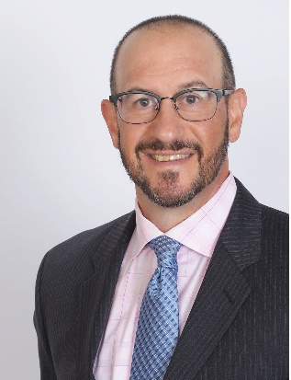
Resides in: Highland Park, New Jersey
Company: Integrated Pension Services
Role: Managing Director - Institutional Retirement Sales & Marketing
Industry Experience: 27 Years
Favorite News Sources: NAPA Net, ASPPA, 401k Specialist
Favorite Book: For business I like ‘Getting Naked’ by Patrick Lencioni and ‘The No Asshole Rule’ by Dr. Robert Sutton

